Advanced Programming II
DATA VALIDATION SYSTEM
Student Name: Terrence Khumalo
Student Number: 0605135282081
Lecturer: Mr Owami
Submission Date: 20 September 2026
GitHub Repository: https://github.com/TerryTrades/validation-system

Table of Contents
1. Introduction
2. System Design
3. Fields
4. Validation Checks
5. Testing
6. Code Walkthrough
7. GitHub Repository
8. Conclusion
9. References

1. Introduction
The Data Validation System is a small desktop application developed in Java using Swing. The purpose of the system is to collect personal information through a simple graphical interface and check that the information makes sense before it is accepted. Instead of allowing a user to submit incomplete or incorrectly formatted information, the application gives a clear message next to the relevant field so the user can see what needs to be fixed.
I approached the project as a practical validation form rather than just a collection of text boxes. The interface was kept clean and straightforward so that someone using the program for the first time can understand what to enter without needing technical knowledge.
The assignment brief requires presence, type, length, format and range checks, together with clear feedback and a Save/Clear/Exit workflow. The project also requires Java Swing, organised code, a README and a public GitHub repository with meaningful progress.

2. System Design
Before coding the form, I planned the layout around three ideas: make the labels easy to scan, keep the input boxes aligned, and show validation feedback immediately beside the field that needs attention. The application uses a light background with a white form panel, dark blue headings and blue action buttons. This was chosen to make the interface feel more like a finished application than the default grey Swing layout.
The form uses a GridBagLayout so the labels, input controls and validation messages remain aligned. The bottom of the screen contains Save, Clear and Exit buttons. Save performs the full validation, Clear resets the form, and Exit closes the application.
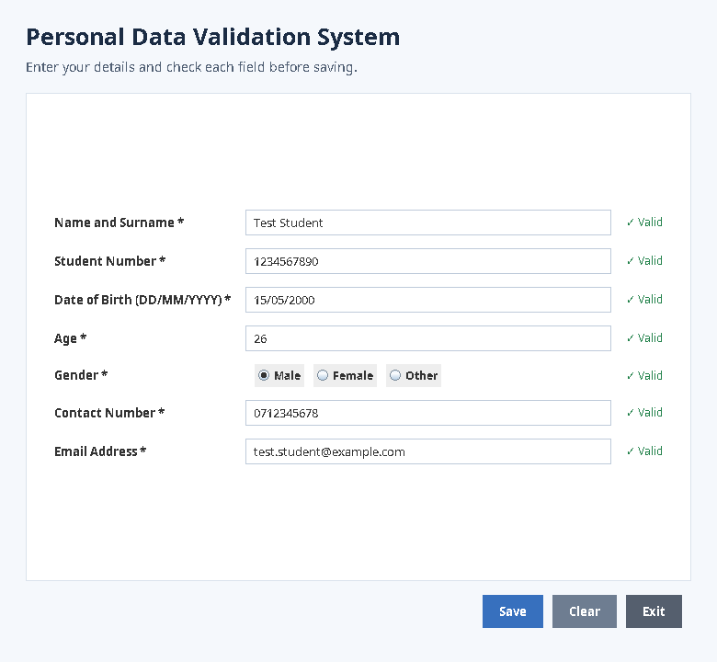
Figure 1: Completed interface with valid test data.

3. Fields
Field | Purpose | Input expected
Name and Surname | Captures the user's full name. | Letters and spaces, 2–60 characters
Student Number | Identifies the student. | Digits, 8–15 characters
Date of Birth | Captures the user's date of birth. | DD/MM/YYYY
Age | Captures the user's age. | Number from 16 to 100
Gender | Records the selected gender. | One radio-button choice
Contact Number | Captures a telephone/contact number. | 10–15 digits
Email Address | Captures an email address. | Email-style format, max 100 characters

4. Validation Checks
The validation logic was designed around the five checks specified in the assignment brief: presence, type, length, format and range. The brief states that each check must give immediate, clear feedback and explain why an input passed or failed.
Field | Checks applied | Why the checks matter
Name and Surname | Presence; type/character check; length check. | Prevents empty names, numbers and unusually short/long names.
Student Number | Presence; numeric type; length. | Ensures the student number contains digits and has a sensible length.
Date of Birth | Presence; format; day/month/year range. | Keeps the date consistent and prevents clearly unrealistic dates.
Age | Presence; numeric type; range. | Prevents letters and values outside the application's sensible age range.
Gender | Presence/selection check. | Ensures one option has been selected before saving.
Contact Number | Presence; numeric type; length. | Prevents letters and incomplete telephone numbers.
Email Address | Presence; format; length. | Checks that the address has a recognisable email structure and is not excessive in length.

5. Testing
Testing was carried out by deliberately entering incorrect values first and then replacing them with valid values. This follows the assignment requirement for evidence of both invalid input with feedback and valid input being accepted.
The screenshots below are generated from the working Java Swing application. They currently use neutral test data so that the project package does not contain personal information that was not supplied in this request. Replace the test data/screenshots with your own details before final submission if your lecturer requires the evidence to show your personal information.
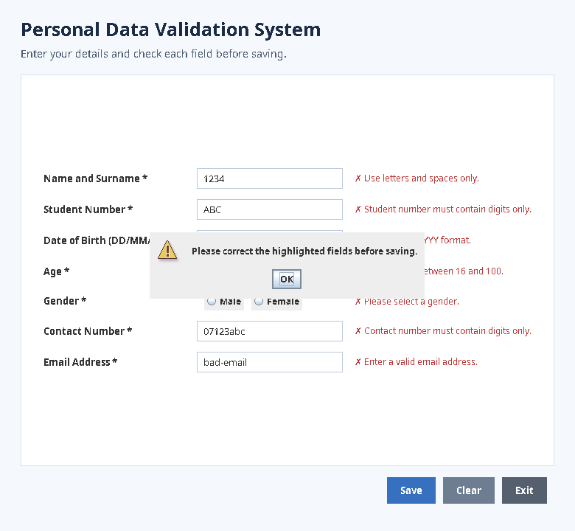
Figure 2: Invalid-input testing. The application rejects incorrect values and explains what must be corrected.
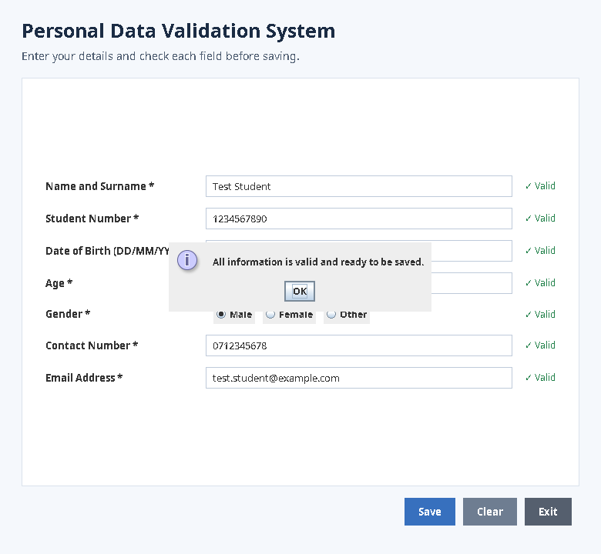
Figure 3: Valid-input testing. The application reports that the information is valid.
Figure 4: Final completed form showing all fields passing validation.

Testing Summary
- Name: letters and spaces accepted; numeric input rejected.
- Student number: digits accepted; alphabetic input rejected; length is checked.
- Date of birth: DD/MM/YYYY format is required and basic date ranges are checked.
- Age: numeric input is required and the value must be between 16 and 100.
- Gender: the user must select one radio-button option.
- Contact number: digits are required and the length must be between 10 and 15 digits.
- Email: a basic email pattern is required and a maximum length is enforced.
- When all checks pass, a success dialog confirms that the information is ready to be saved.

6. Code Walkthrough
The source code is kept in one main Java class for this assignment. The class extends JFrame, which makes the main application window, while separate methods keep the interface creation and validation logic readable.

Creating the window
public DataValidationSystem() {
setTitle("Personal Data Validation System");
setDefaultCloseOperation(JFrame.EXIT_ON_CLOSE);
setSize(780, 720);
setLocationRelativeTo(null);
...
}
These lines create the main Swing window, set its title and size, and place it in the centre of the screen.

Running all validation checks
private boolean validateAll() {
boolean valid = true;
valid &= validateName();
valid &= validateStudentNumber();
valid &= validateDateOfBirth();
valid &= validateAge();
valid &= validateGender();
valid &= validateContact();
valid &= validateEmail();
...
}
I used a separate method for each field so that each rule is easier to understand and maintain. The final boolean value determines whether the success or warning message is shown.

Example: name validation
private boolean validateName() {
String value = nameField.getText().trim();
if (value.isEmpty()) return fail(nameStatus, "Required: enter your name.");
if (!value.matches("[A-Za-z ]+"))
return fail(nameStatus, "Use letters and spaces only.");
if (value.length() < 2 || value.length() > 60)
return fail(nameStatus, "Name must be 2–60 characters.");
return pass(nameStatus);
}
This method checks whether a name was entered, checks that only letters and spaces were used, and then checks the length.

Example: email validation
String pattern = "^[A-Za-z0-9+_.-]+@[A-Za-z0-9.-]+$";
if (!Pattern.matches(pattern, value))
return fail(emailStatus, "Enter a valid email address.");
The email check uses a regular expression to look for a basic email structure. It then applies a maximum length check.

Clear feedback
private boolean pass(JLabel label) {
label.setForeground(SUCCESS);
label.setText("✓ Valid");
return true;
}
private boolean fail(JLabel label, String message) {
label.setForeground(ERROR);
label.setText("✗ " + message);
return false;
}
Keeping the success and error feedback in two small methods makes the interface consistent. Every field gets the same type of feedback.

7. GitHub Repository
The assignment requires the finished project to be placed in a public GitHub repository, with a meaningful commit history, a README explaining the project and instructions for running it.
https://github.com/TerryTrades/validation-system

8. Conclusion
Completing this project helped me understand that validation is not only about preventing an application from crashing. It is also about helping the person using the application understand what went wrong and how to fix it. I separated the validation rules into smaller methods because this made the program easier to read and made it simpler to test each field individually.
One of the main design decisions was to avoid relying on default Swing styling. I wanted the form to look organised and intentional, while still keeping the interface simple. The testing stage also showed why both invalid and valid test cases are important: a system should reject bad data for the right reason and accept good data without creating unnecessary obstacles.
Overall, the project gave me practical experience with Java Swing components, event handling, regular expressions, input validation, user feedback and structuring a small desktop application.

9. References
Gauteng City College. Advanced Programming II: Assignment Brief Data Validation System (Java Swing), 2026.
Oracle. Java Platform documentation, Swing and Java language documentation. Accessed during development.
Java Swing API documentation and regular expression concepts were used to understand implementation details.

